** PROJECT REPORT TEMPLATE**

1. **INTRODUCTION** 
   1. Overview

Designing a Youtube Thumbnail using Canva

* 1. Purpose

We created a youtube thumbnail for our college women’s day celebration

1. **PROBLEM DEFINITION & DESIGN THINKING** 
   1. Empathy Map

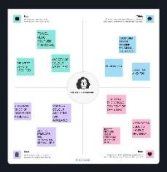

* 1. Ideation & Brainstroming

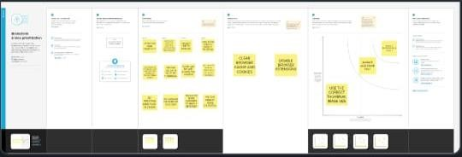

1. **RESULT**



1. **ADVANTAGES AND DISADVANTAGES**

It is useful to create youtube thumbnail to attract views

The disadvantage of creating youtube thumbnail in canva is limitation of templates

1. **APPLICATIONS**

It was helpful to create youtube thumbnail attract targeted audience

1. **CONCLUSION**

Canva is helpful app to create and edit content. It enhances our creative skills